Report on App Design proto typing

Date: 10-2-2016
Participants: 107
Resource Person : Mr. Mohith R Hegde, Director, Creative infotech
The main objective of this one day work shop is to make participants understand application design prototyping which is an excellent tool for analyzing and designing an interactive application and/or a user interface and to support object-oriented system development. During the analysis stage, prototyping can be used to replace or supplement logical modeling, particularly when the users are uncomfortable with abstract models. Prototyping is valuable on projects with long development times because the user gets to see something physical. Prototyping is an excellent tool when the requirements are highly uncertain or too abstract to specify, or when no comparable system has been previously developed. Generally, if reaching a solution calls for simulation, experimentation, or incremental evaluation, prototyping might be a reasonable choice.
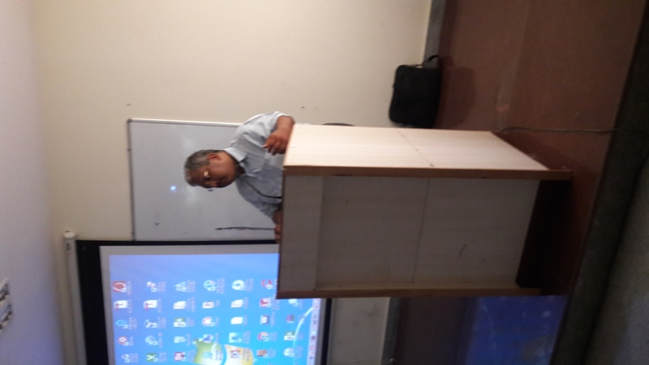

Session on application design prototyping
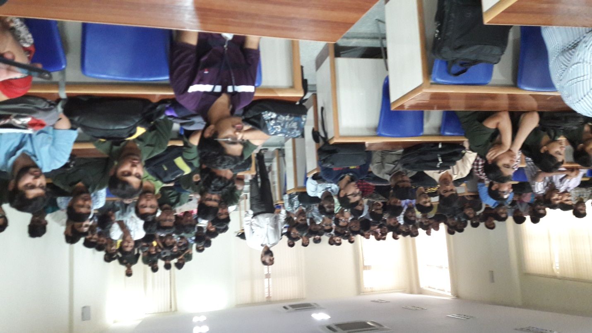
It can be used as interactive, i.e., exchange of ideas . It gave an insight in to the best practices used in industry for app design, various tools used in creative app prototype, hands on session for creating app prototype using tools.
Student participants

Summary: Prototyping is a powerful, bottom up alternative or supplement to logical modeling. The basic idea is to build a reasonably complete, working, physical model (or prototype) of the system. As a minimum, the analyst can use screen painters, menu builders, and report generators to prepare a “slide show” of sample screens , dialogues , and reports . In a more complete prototype, preliminary working versions of the system’s programs are created using a fourth-generation language, spreadsheets, database software, or a similar end-user tool.

