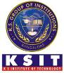
K.S.INSITITUTE OF TECHNOLOGY
Department of Telecommunication Engineering
Report on
Technical Talk- 25th February 2020

A Technical Talk on “Enroute College to Corporate”, by Mr. Nishith H M, Alumni 2016 batch, was organized by Department of Telecommunication Engineering K.S.I.T on 25th of February 2020 in TCE Department. The Seminar began with a welcome speech introducing the resource person to the audience i.e. 8th and 6th Semester Students.

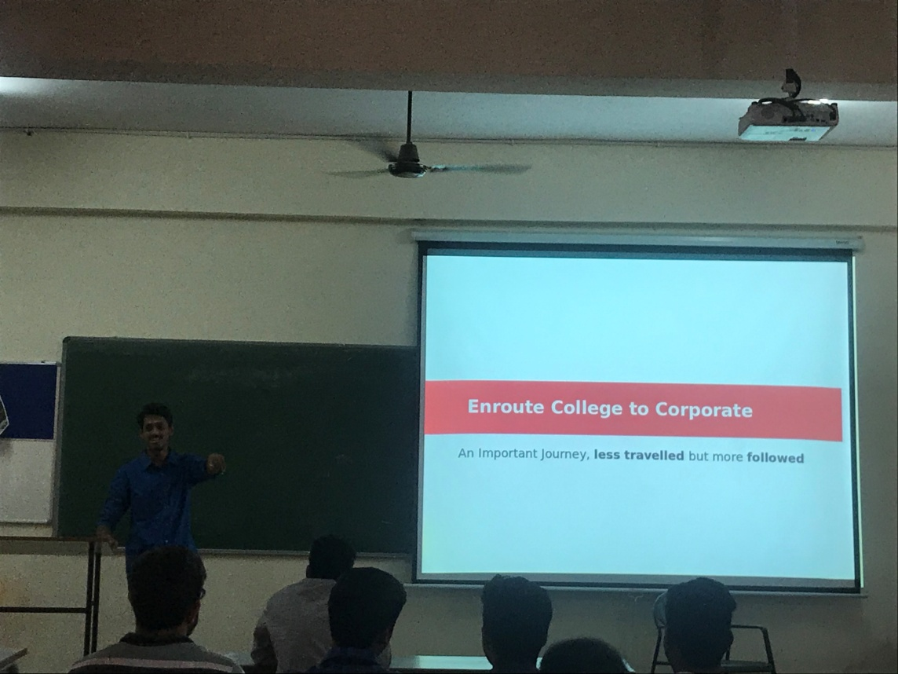

Mr. Nishith H M was a very motivational speaker, he shared with us his knowledge on Busting Myths ,Time Flies and Trends . During the session he spoke to the crowd with great interaction which allowed the crowd to involve with him in the talk.
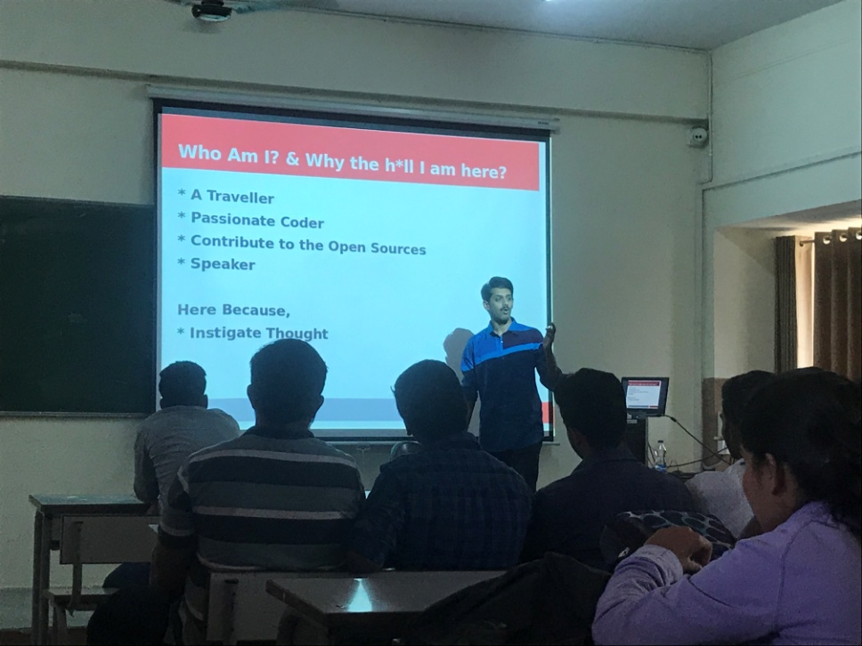

He mainly focused on the following aspects:

- Aptitudes
- Group Discussions
- Technical Round
- Personal Interview
- Handle rejections
- Difference between college and corporate
- Time Flies
- Trends and Trend Setters
- Industry and corporate trends
- College trends
- A better way of training mind

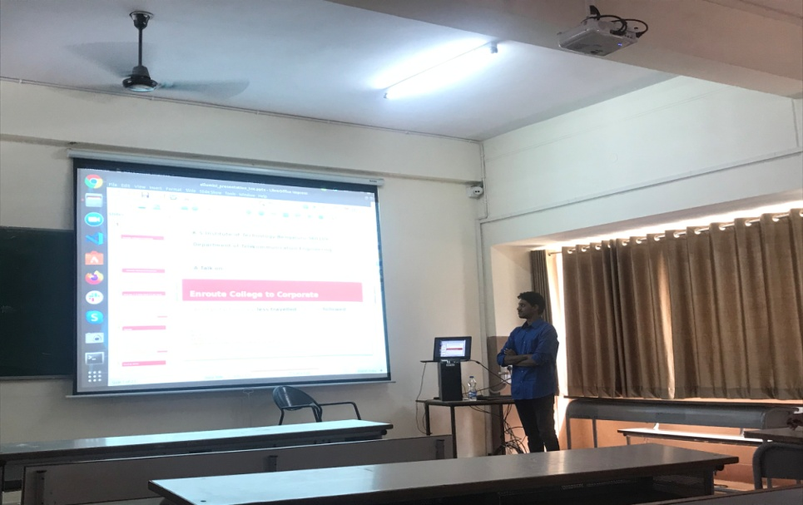
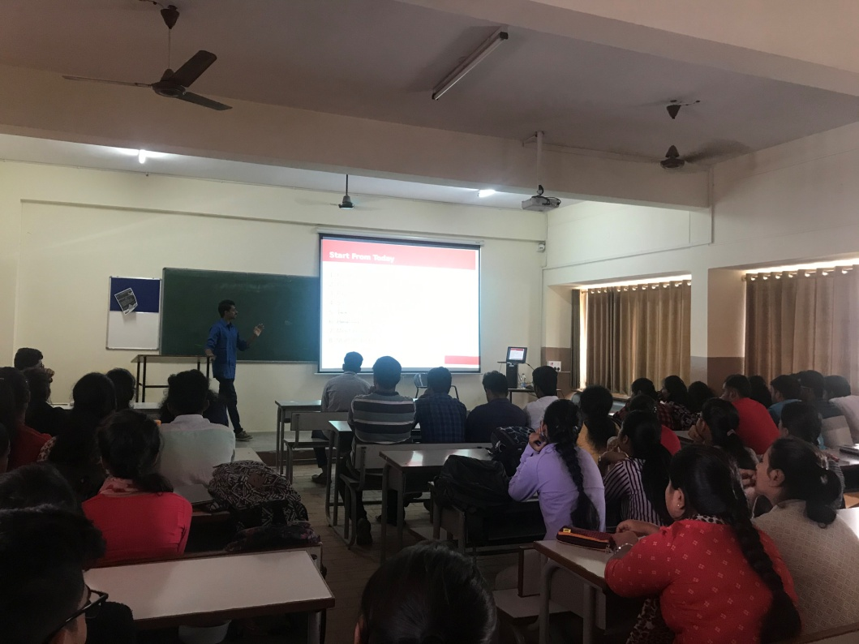

On the whole the Talk was educative on both theoretical as well as Practical aspects. Overall 60 Students from sixth semester TCE were involved. The talk was very helpful to all the students who are finding it difficult to decide on which programming courses to be taken up next.
It also motivated students to learn new technologies and programming languages. The Talk ended with vote of thanks. All the students liked the session very much and are looking forward to many more like this.

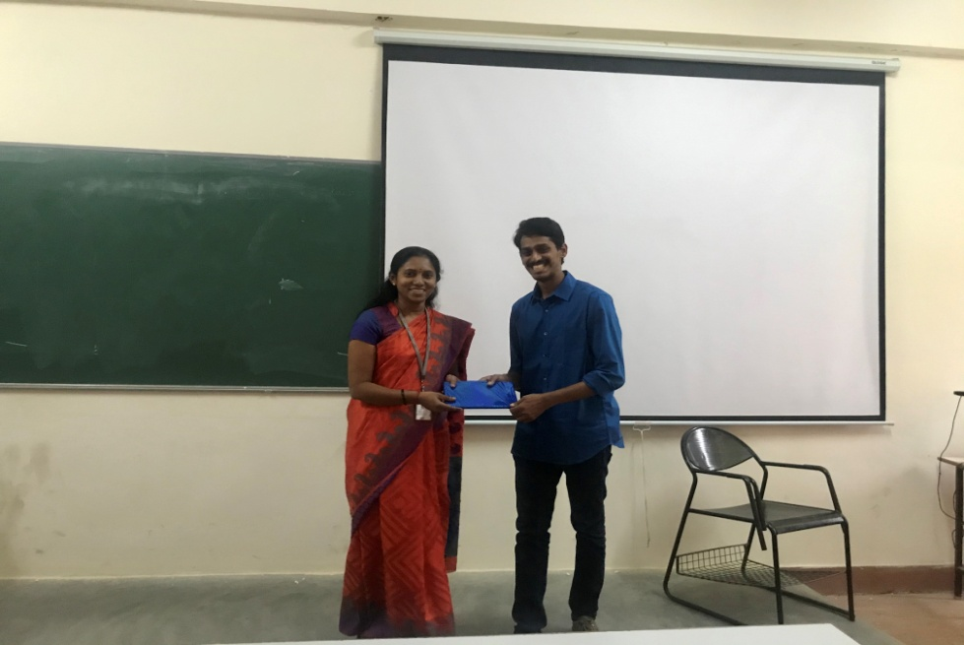

The entire Department thank Principal and Management for supporting us throughout the event and making this event a successful one.

Mapping of workshop with PO’S and PSO’S
Program | PO1 | PO2 | PO3 | PO4 | PO5 | PO6 | PO7 | PO8 | PO9 | PO10 | PO11 | PO12
Technical Talk | 1 | 1 | 1 | 1 | 1 | - | - | - | - | 1 | - | 2

- PO1: Students gained the knowledge of engineering fundamentals.
- PO2: Students can be able to analyze complex engineering problems.
- PO3: Students can be able to apply the knowledge in designing new webpages.
- PO4: Students can identify complex problems for research work.
- PO5: Students can utilize modern tools for research work.
- PO10: Students can communicate effectively by gaining knowledge.
- PO12: Students can apply the basic knowledge in lifelong learning of new programming languages.

Rekha N Dr. Chanda.V. Reddy
Co-ordinator HOD

