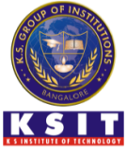
K.S. INSTITUTE OF TECHNOLOGY, 560109
DEPARTMENT OF COMPUTER SCIENCE & ENGINEERING
ISTE Professional Body Events
Academic Year | Title | Event | Resource Person  and details | Date | No. of Participants | Objective of Event | PO’s | Photo
2020-21 | Design Innovation for Successful Career in the field of Aviation for CSE Students” on | Webinar | Mr. Dhanish Abdul Khader  Space Systems Engineer,  SS Technologies  Bangalore. | 17-7-2021 | 97 | Awareness on opportunities for CSE Professionals in Aviation | PO1,PO5,PO7,PO12,PS01 | 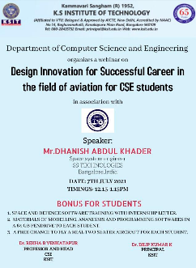
 | AWS Cloud Practioners Essentials” | Workshop | 1. Dr. Prakash, Principal, East Point College of Engineering &amp; Technology, Bengaluru  2. Mrs. Shefali Arora, Asst. Prof. Dept. of ISE, East Point College of Engineering &amp; Technology, Bengaluru  3. Mrs. Nandini Gowda, Asst. Prof. Dept. of ISE, East Point College of Engineering &amp; Technology,  Bengaluru | 21-7-2020 & 22-7-2020 | 70 | Practical Approach on AWS cloud essentials | PO1, PO2, PO3, PO5, PO6,PO9,PO12,PS01,PS02 | 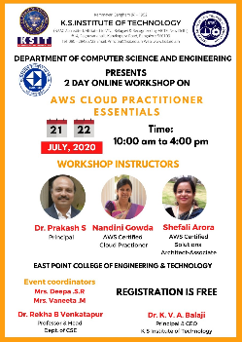
2019-20 | Swift: Smart World Through Innovative Future Technology | 16th Karnataka State Level ISTE Student Convention | Chief Guest  Mr. Tejasvi Surya  Member of Parliament Bengaluru South  Guest of Honour  Dr. C. K. Subbaraya, Past Chairman, ISTE Karnataka  Dr. D. S. Suresh,Chairman, ISTE Karnataka | 22-02-2020 | 552 |  | PO1,PO2,PO3,PO5,PO6,PO7,PO8,PO9,PO10,PO11,PO12 | 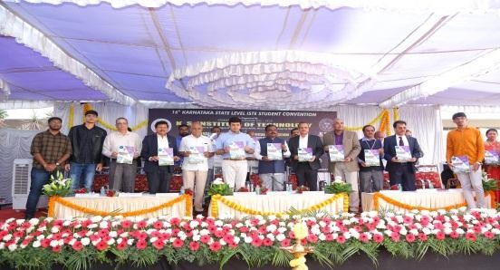
2018-19 | “Awareness on Digital Marketing” | Guest Lecture | Ms. Anjali Mehta  Academic Director,  PAAGC Digital Web Academy  Bangalore | 15-10-2018 | 76 | Understand the importance and job opportunities in digital marketing | PO1, PO2, PO3, PO5, PO6,PO10, PO12,PSO1,PSO2 | 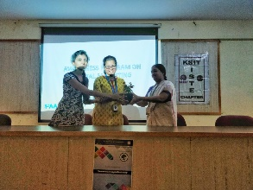
2016-17 | Artificial Intelligence | Technical Talk | Organized by KSIT-CSE and Anita Borg Institute (ABI)  The resource person is Ms. Hima M Patel ,research scientist in Shell Technology Centre, Bangalore. | 29-09-2016 | 120 | Awareness of importance of Artificial Intelligence | PO5,PO4,PO5,PO6, PO12, PSO1,PSO2 | 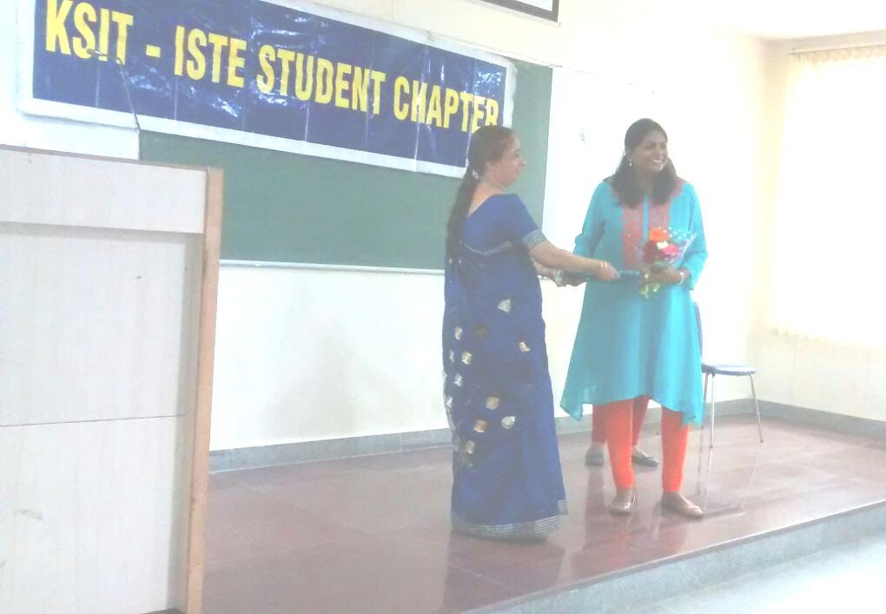
 | Android and Web Application Development(ISTE) | Workshop | Mr. Anupam, CEO, Dr.Code | 3-10-2015 &  4-10-2015 | 43 | Enhance Practical kowledge on android app development | PO1,PO2,PO3,PO5,PO6,PO7,PSO1,PSO2 | -
 | 'Opportunities & Trends in Animation, Visual Effects and Gaming Industry'(IEI) | Technical Talk | by ICAT Design and Media | 9-3-2016 | 100 | Awareness on Animations, Visual Effects | PO1,PO2,PO3,PO5,PO7,PSO1,PSO2 | 