Report
WORKSHOP ON ROBOTICS AND AEROMODELLING

The Garut Aeromodelling club, in association with IEEE KSIT and Department of Electronics and Communication Engineering organized a two days’ workshop on Robotics and Aeromodelling on 26th and 27th December, 2022. The event featured external trainers who instructed students on the principles of aeromodelling and robotics. Approximately 20 teams, each comprising of 40 members, took part in the workshop.
The event was inaugurated by Mr. Christo and Dr. Dinesh in the ECE seminar hall at 9am, which was followed by the introduction of the external trainers by Srinivasan.M.
Nishanth.K is a highly qualified Embedded Systems Engineer working at Keysight Technologies.
V Ranjith Kumar is also an Embedded Systems Engineer and PCB Designer who is employed as Embedded Design Engineer in Cambrian Consultancy Centre and Industrial Research.
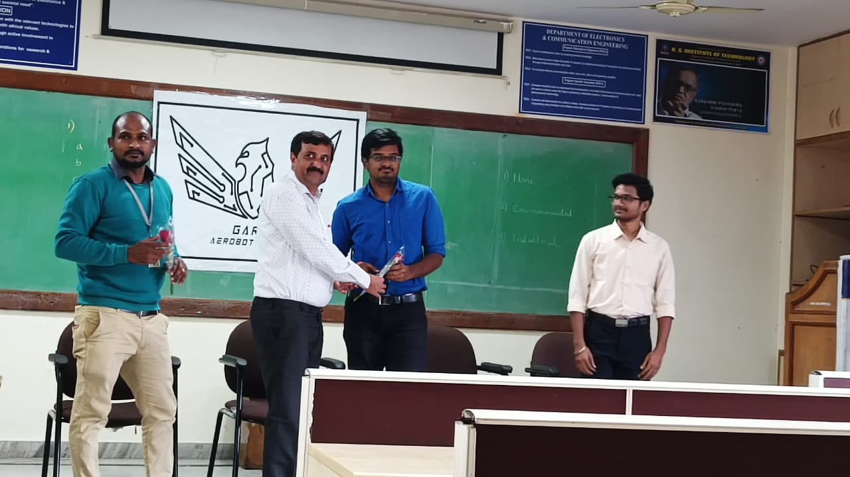
On the first day of the workshop, the attendees were introduced to the basics of aerodynamics and were guided in the construction of Hydro Rocket Models. 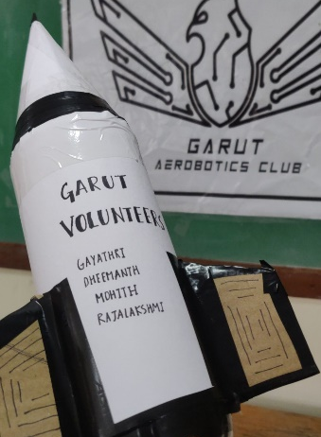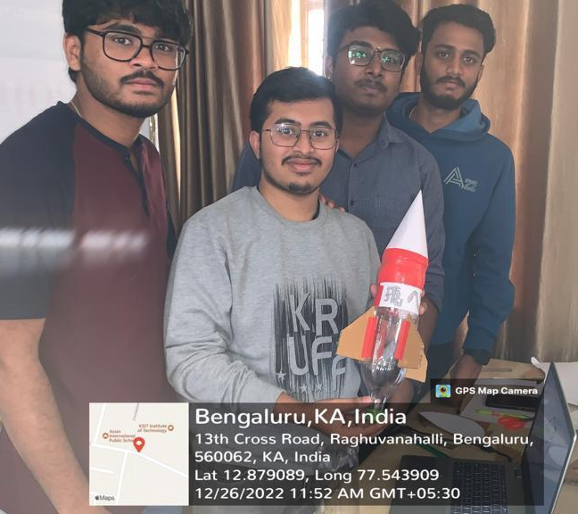
The students then had the opportunity to launch their completed rockets in the college quadrangle. Winners were announced based on the height the rockets covered.
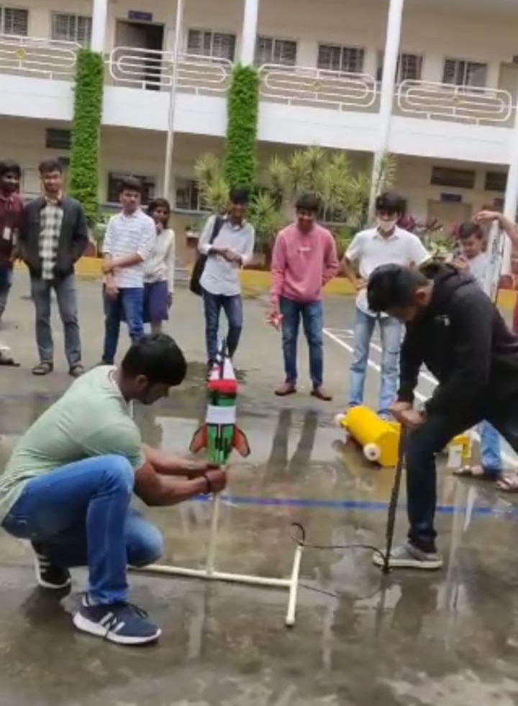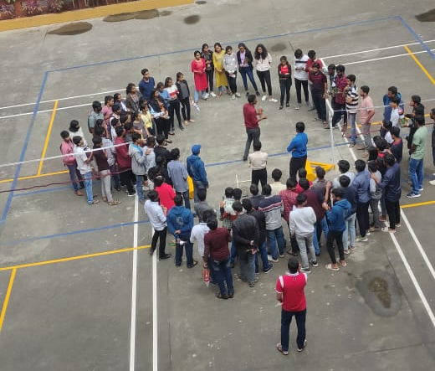
In the afternoon, participants received training on basics of Python and computer vision algorithms using Python and implemented mini projects with these techniques.

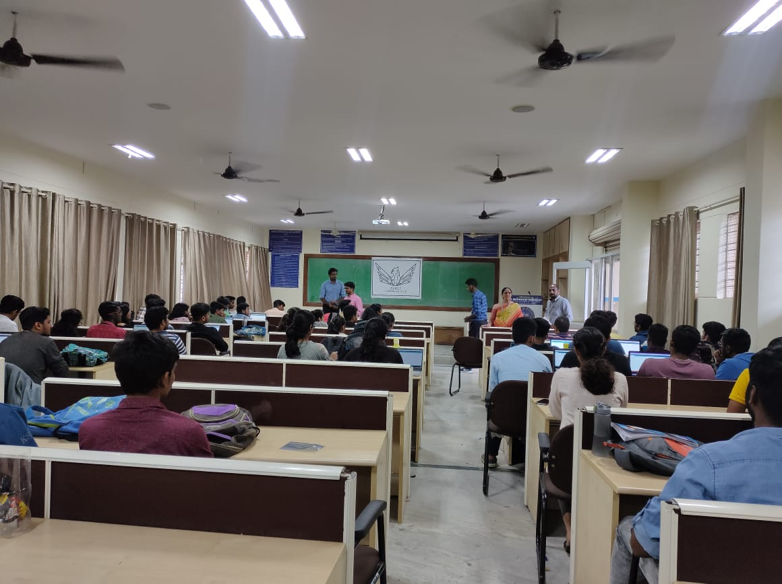
On the second day, further computer vision projects were demonstrated and the students were trained on the use of the Intel Galileo Board to build robotics-related mini projects. They also received instructions on how to interface computer vision algorithms with the Intel Galileo Board.

The mini projects that were implemented by the students during the workshop:
Document Scanner app: This project involved using image processing algorithms, such as edge detection, to convert a given image of a document into a PDF format. Edge detection is a technique that can be used to identify the boundaries of objects in an image, which can then be used to separate the object from the background. Once the document is separated from the background, image processing algorithms can be used to clean up the image, such as removing noise or adjusting the contrast. The final result is a clean, easy-to-read PDF document.
Webcam background blur: This project involved creating a feature that can change the background image of the user during a video call. This is commonly used in video conferencing apps like Zoom, Microsoft Teams, and Google Meet to improve the user's privacy or to make it look like they are in a different location. The feature is built using techniques like chroma keying, which is a technique used to isolate a specific color or range of colors in an image, and then replace that color with a different image.
Snapchat Filters: Snapchat filters are a popular feature in the app that allow users to apply different effects to their photos and videos. The filters are based on several image processing techniques and algorithms. The students were trained on few of the techniques that can be used to implement a snapchat like filters. This may include feature recognition using deep learning, Object recognition and tracking, Facial expression recognition and so on.
Face Detection: This project involved building a machine learning model that could detect faces in images with a high degree of accuracy. Face detection is widely used in various projects for authentication and security purpose. The students were trained on how to use openCV library, dlib and other libraries to implement this project. This model can be further used to create projects like Face-based door lock systems and Face-based attendance systems.
Computer vision based robotic projects: This project involved training students on how to interface the computer vision projects like face detection with the intel Galileo board to create real-time hardware projects. This might include projects like face detection based door lock system and a face detection based attendance system, where students could apply the knowledge on face detection model to open a door or mark attendance.
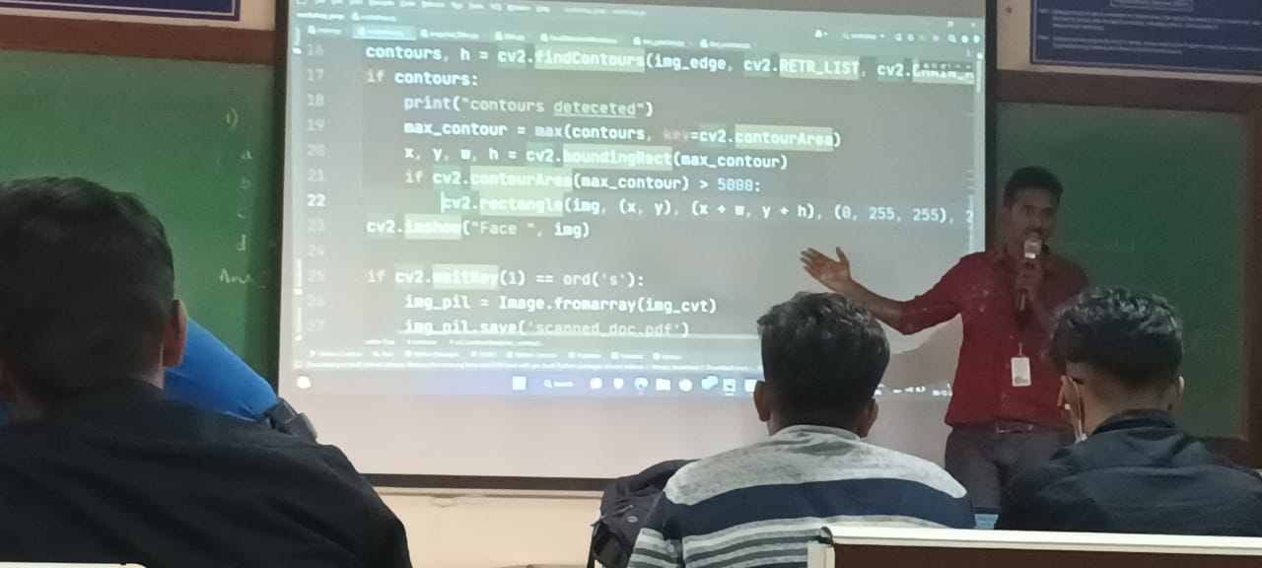

The workshop provided students with a good hands-on experience in applying these techniques to real-world scenarios. The workshop was a great success, with students gaining valuable hands-on experience in the field of Robotics and Aeromodelling. The ability to learn and apply new techniques such as image processing, edge detection, feature recognition and others, will be beneficial for the students in their mini projects and final year engineering projects. It was great to hear that the students enjoyed the workshop and had a positive feedback, such as – experiencing fun and interactive learning, having hands-on experience, and having the opportunity to launch their own rocket models. This type of positive feedback highlights the success of the workshop and the dedication of the trainers and organizers.

Finally, Dr. P N Sudha, the HOD of Dept. of ECE, addressed the students, appreciated the students for their active participation in the workshop, acknowledged the winners, wished them for their future endeavours and thanked the trainers for their effort and support for the grand success of the workshop. While addressing the gathering, she also encouraged the participants to implement the learnt topics in their upcoming projects.
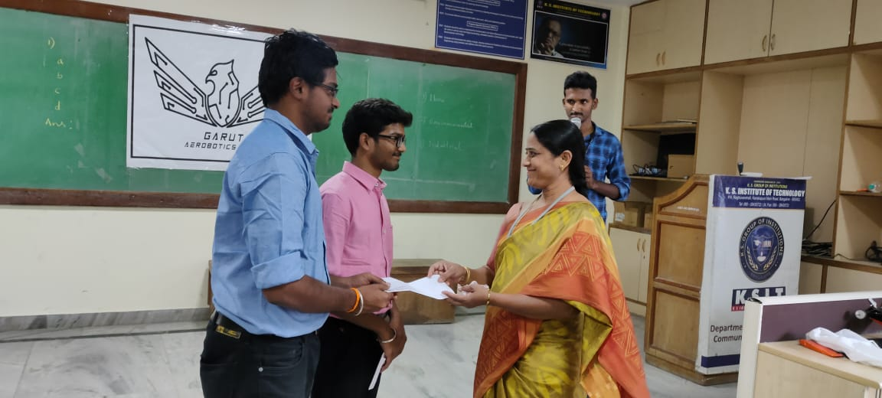

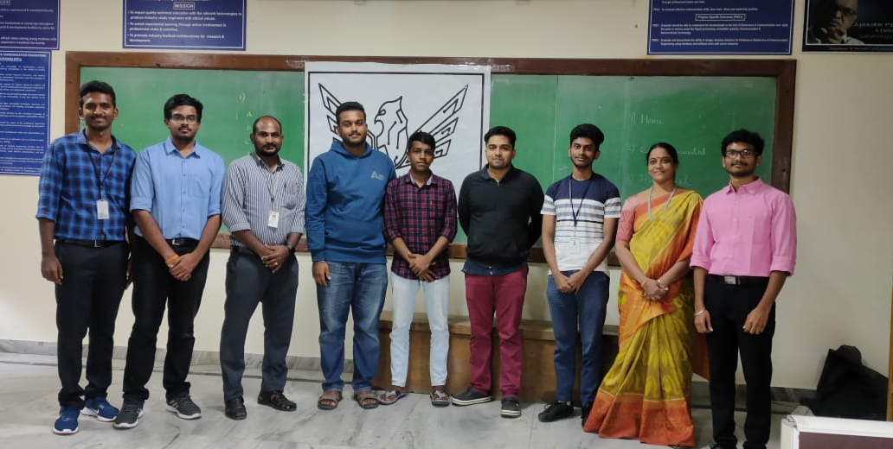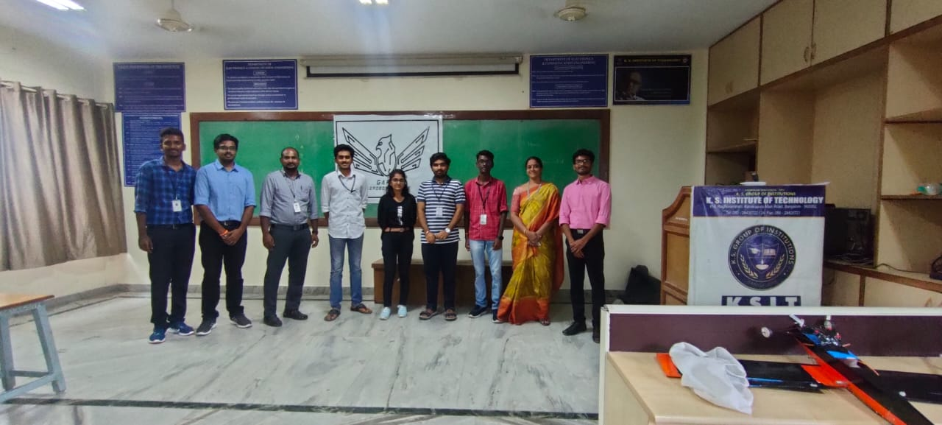

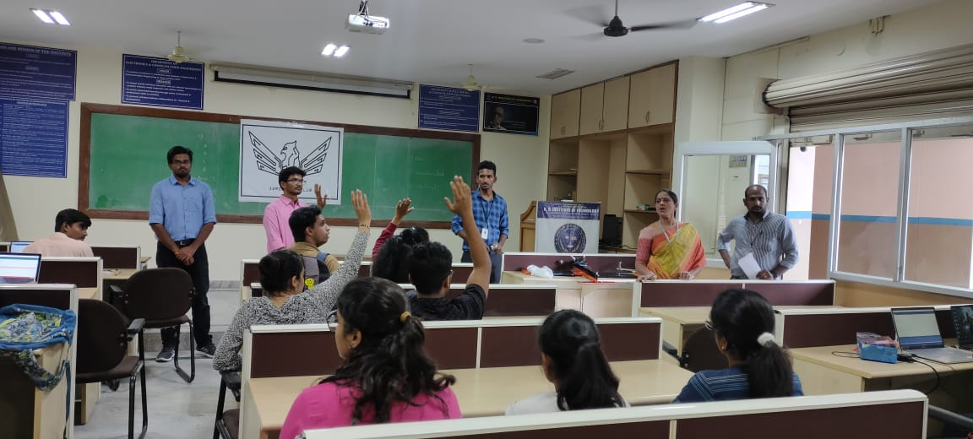

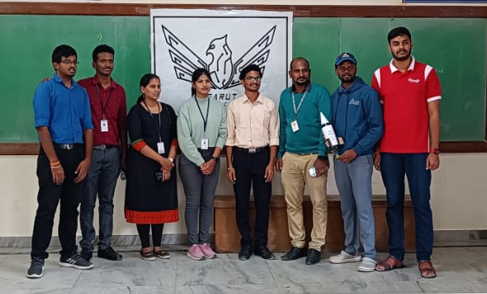

PO MAPPING:
POs | PO1 | PO2 | PO3 | PO4 | PO5 | PO6 | PO7 | PO8 | PO9 | PO10 | PO11 | PO12
Mapping  Strength | 3 | 2 | 3 |  | 3 | 2 |  |  | 3 | 2 | 2 | 2

