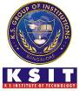
K. S. INSTITUTE OF TECHNOLOGY
#14, Raghuvanahalli, Kanakapura Road, Bangalore-560109.
Faculty Name | Geeta Katti | 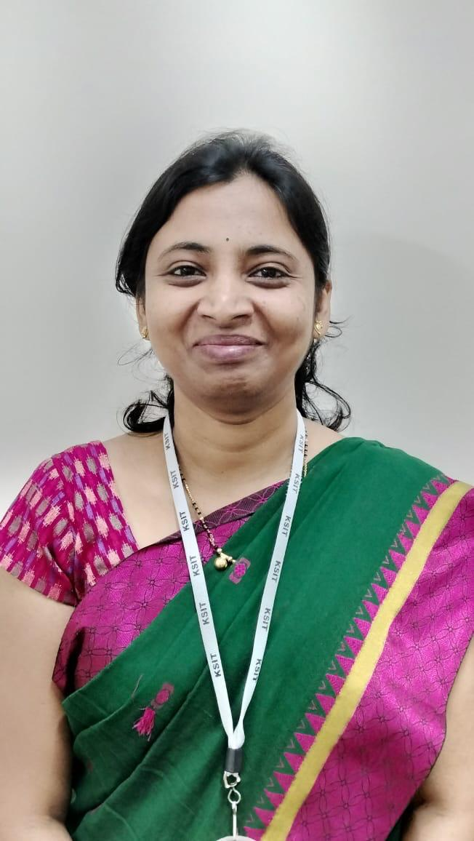
Designation | Assistant Professor
Educational Qualification | M.Tech
Experience in Years | 1
Areas of Interest | Database Management
E-mail | geethakatti@gmail.com

Educational Details
Examination/  Degree | College / University | Year of  Passing
UG | B.E | 2010
PG | M.Tech | 2012
PhD

Publications
Awards
Professional Membership
Contact Details

