K. S. INSTITUTE OF TECHNOLOGY

#14, Raghuvanahalli, Kanakapura Road, Bangalore-560109.
Faculty Name | Dr JALAJA P | 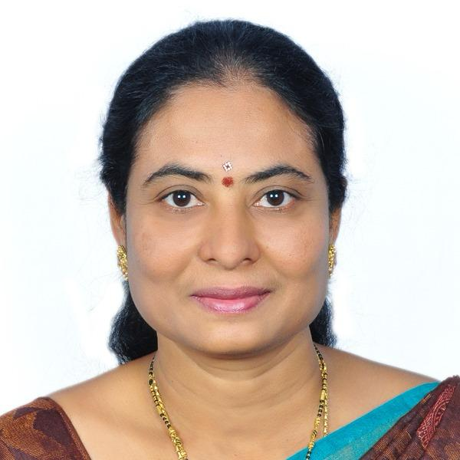
Designation | PROFESSOR
Educational Qualification | M.Sc , M.Phil ,Ph.D.
Experience in Years | Teaching: 25 YEARS  Industry : - NIL Research: 6 YEARS
Areas of Interest | Fluid Dynamics
E-mail | jalajap@ksit.edu.in

Educational Details
 | Examination/  Degree | College / University | Year of  Passing
 | UG | Sri padmavathi womens college, Tirupathi. S.V.university,  Tirupathi | 1996
 | PG | Sri padmavathimahila visva vidyalayam,Ttirupathi | 2001
 | M.phil | M.K.University,Madhurai | 2003
 | PhD | Visvesvaraya Technological University, Belgaum, Karnataka. | 2021
Publications
Journal Publications:
INTERNATIONAL JOURNALS :

- “ THERMAL RADIATION EFFECT ON MHD NATURAL CONVECTION BOUNDARY LAYER FLOW OVER A PLATE WITH SUCTION (INJECTION)
AND VARIABLE VISCOSITY” , International Journal of Research- GRANTHAALAYAH , A Knowledge Repository ,Vol.5 (Iss.4: RAST), April, 2017, pp. 52~58 by Jalaja. P, Venkataramana.B.S, Naveen.V, Dr. K.R.Jayakumar.
- “ The Effect of Viscous Dissipation on MHD nonsimilar Boundary Layer Flow with an Exponentially decreasing Velocity Distribution” International Journal of Research
in Engineering and Applied Sciences (IJREAS), Vol. 7 Issue 6 , June-2017, pp. 121~128,

by P.Jalaja, B.S. Venkataramana, K.R.Jayakumar.

- “ Modelling and Optimization of Double Choking Ejectors for Refrigeration Systems” TEST Engineering & Management (SCOPUS INDEXED JOURNAL) Volume 82, Publication Issue: January-February 2020, 28 February 2020, Page Number: 14580 – 14586 , ISSN: 0193 – 4120 , by Jalaja.P, and Dr. Shivakumar H.M.

“COMPUTATIONAL ANALYSIS OF MICRO CHANNEL PATH OPTIMIZATION OF HEAT EXCHANGER BASED ON THERMAL BOUNDARY
CONCEPT”. Purakala ( UGC Care Journal ) Volume -31 , Publication Issue : 04 April 2020 ,Page Number : 868 – 886 , ISSN : 0971-2143 , by Jalaja.P and Dr.Shivakumar H.M.

NATIONAL CONFERENCES :
- “ The Effect of Mass Transfer Parameter on Forced Convection Boundary Layer Flow over a Flat Plate with an Applied Magnetic Field” , National Conference On Scientific, Computational & Information Research Trends in Engineering (NCSCI- 2016), at GSSS Institute of Engineering & Technology for Women, Mysore on 30th JANUARY 2016 by P Jalaja, B S Venkataramana and K R Jayakumar.

- “ Thermal Radiation Effect on MHD Forced Convection Boundary Layer Flow over a Plate” , National Conference on "Advances in Mechanical Engineering and Applied Sciences" (AMEAS-2016) at Dayanda sagar college of Engineering, Bangalore, during February 19th and 20th 2016 by P Jalaja, B S Venkataramana and K R Jayakumar.
- “ The Influence of Variable Viscosity on Natural Convection Flow and Heat Transfer from a Porous Vertical Flat Plate with Constant Heat Flux and Suction (Injection)” , National Conference on Recent Advances in Applied Sciences at AMC College of Engineering, Bangalore on 25th April, 2016 by P Jalaja, B S Venkataramana and K R Jayakumar.

- “ The influence of heat generation (absorption) on unsteady mhd forced convection boundary layer flow and heat transfer over a flat plate” , national conference on convergence of science, technology & management nccstm 2016 at Dayananda Sagar Academy of Technology & Management, Bangalore on 5th May, 2016 by P Jalaja, B S Venkataramana and K R Jayakumar.
- “ Thermal Radiation Effect on Unsteady MHD Forced Convection Accelerating Boundary Layer Flow over a Flat Plate” National conference on An Insight into Analysis and Applications of Mathematics at National College Jayanagar, Bangalore on 24th August 2016 by P Jalaja, ,B S Venkataramana , Naveen.V and K.R.Jayakumar.
- “ Forced Convective Decelerating Flow over a Plate with an Applied Magnetic field” National Conference on Current Advances in Science and Technology (NCCAST – 2017 at KSIT, BANGALORE during 10th - 12th May 2017 by P Jalaja, B S Venkataramana , Naveen.V and K.R.Jayakumar .

INTERNATIONAL CONFERENCES :
- “ The Effect of Thermal Radiation on Laminar Boundary Layer Flow over a Flat Plate with an Exponentially Decreasing Velocity Distribution and an Applied Magnetic Field” , ISTAM 2016 at VIT, Vellore during Dec.11 – 14, 2016 by Jalaja.P Venkataramana.B.S., Naveen.V, Dr.K.R.Jayakumar and Dr.A.T. Eswara.
- “The Effect of Heat generation and Absorption on MHD Laminar Boundary Layer Flow over a Flat Plate with an Exponentially Decreasing Velocity Distribution” , International conference on Mathematical Modeling at Don bosco Institute of Technology during Dec.23 – 24 2016 by Jalaja.P , Venkataramana.B.S., Naveen.V, Dr.K.R.Jayakumr.

“MODELLING OF FLOW IN SUPERSONIC EJECTORS FOR DOUBLE CHOKING CRITERIA FOR REFRIGERATION SYSTEMS”, International
Conference on Recent Advances in Applied Sciences 2019 at REVA University, Bangalore during 17th – 18th October 2019 by Jalaja.P,and Dr. Shivakumar H.M.

- “Optimization Of Electric Vehicle Battery Thermal Management System Using Computational Fluid Dynamics And Thermal Analysis”, International Conference on Recent Innovations in Engineering Science & Technology-(ICRIET-2025) at KSIT Bangalore on 9th MAY 2025 by JALAJA P.

1. PATENT:

IOT-BASED INTELLIGENT AGRICULTURE SYSTEM WITH ARTIFICIAL

INTELLIGENCE published on 13.07.2022
Awards
- Received best paper award at GSSS institute of engineering and technology for women, mysore on 30-01-2016 in National conference.
- Awarded 100 percent results in VTU, PG examinations during December 2017-Jan 2018.
- Received best paper award at KSIT during may 10th to 12th 2017 in National conference.
- Awarded 100 percent results in VTU, UG examinations during JUNE-JULY 2018.
- Received silver medal in Accrediation and outcome based learning(NPTEL course) during Aug-Oct 2024.
- Awarded certificate for successfully completing Advanced Engineering Mathematics (NPTEL Course) during JUL- OCT 2025.
- Received best paper award at KSIT during may 9th to 10th 2025 in International conference.
Professional Membership
- ISTAM
Contact Details
Name: JALAJA P
Official Address: #14, Raghuvanalli, Kanakapura Road, Bengaluru -109 Phone Nos: 080 28435722 Extension 602
Alternate Email: jalajap@ksit.edu.in

