K. S. INSTITUTE OF TECHNOLOGY

#14, Raghuvanahalli, Kanakapura Road, Bangalore-560109.
Faculty Name | NAVEEN V | 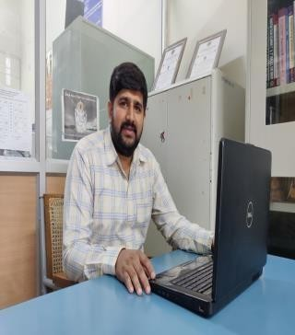
Designation | Assistant Professor
Educational Qualification | M.Sc , (Ph.D).
Experience in Years | Teaching:12.3 YEARS  Industry : - NIL
Areas of Interest | Fluid Dynamics
E-mail | naveenv@ksit.edu.in

Educational Details
 | Examination/  Degree | College / University | Year of  Passing
 | UG | SSMRV Degree college Bangalore, Bangalore University | 2010
 | PG | MES College Bangalore, Bangalore University | 2012
 | PhD | Visvesvaraya Technological University, Belgaum, Karnataka.
Publications
Journal Publications:
INTERNATIONAL JOURNALS :

1. “ THERMAL RADIATION EFFECT ON MHD NATURAL CONVECTION BOUNDARY LAYER FLOW OVER A PLATE WITH SUCTION (INJECTION)
AND VARIABLE VISCOSITY” , International Journal of Research- GRANTHAALAYAH , A Knowledge Repository ,Vol.5 (Iss.4: RAST), April, 2017, pp. 52~58 by Jalaja. P, Venkataramana.B.S, Naveen.V, Dr. K.R.Jayakumar.

NATIONAL CONFERENCES :

- “ Thermal Radiation Effect on Unsteady MHD Forced Convection Accelerating Boundary Layer Flow over a Flat Plate” National conference on An Insight into Analysis and Applications of Mathematics at National College Jayanagar, Bangalore on 24th August 2016 by P Jalaja, ,B S Venkataramana , Naveen.V and K.R.Jayakumar.
- “ Forced Convective Decelerating Flow over a Plate with an Applied Magnetic field” National Conference on Current Advances in Science and Technology (NCCAST – 2017 at KSIT, BANGALORE during 10th - 12th May 2017 by P Jalaja, B S Venkataramana , Naveen.V and K.R.Jayakumar .

INTERNATIONAL CONFERENCES :
- “ The Effect of Thermal Radiation on Laminar Boundary Layer Flow over a Flat Plate with an Exponentially Decreasing Velocity Distribution and an Applied Magnetic Field” , ISTAM 2016 at VIT, Vellore during Dec.11 – 14, 2016 by Jalaja.P Venkataramana.B.S., Naveen.V, Dr.K.R.Jayakumar and Dr.A.T. Eswara.
- “The Effect of Heat generation and Absorption on MHD Laminar Boundary Layer Flow over a Flat Plate with an Exponentially Decreasing Velocity Distribution” , International conference on Mathematical Modeling at Don bosco Institute of Technology during Dec.23 – 24 2016 by Jalaja.P , Venkataramana.B.S., Naveen.V, Dr.K.R.Jayakumr.

Awards
- Awarded 100 percent results in VTU,UG examinations during JUNE-JULY 2018.
- Awarded 100 percent results in VTU,UG examinations(4thsem CS) during 2022
- Awarded 100 percent results in VTU,UG examinations (2nd Sem) during 2022.
- Awarded 100 percent results in VTU,UG examinations (3rd sem) during 2024.
Contact Details
Name: NAVEEN V
Official Address: #14, Raghuvanalli, Kanakapura Road, Bengaluru -109 Phone Nos: 080 28435722 Extension 602
Alternate Email:naveen_201182@yahoo.com

