K.S. INSTITUTE OF TECHNOLOGY
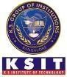#14, Raghuvanahalli, KanakapuraRoad, Bangalore-560109.
FacultyName | SUPRIYA M D | 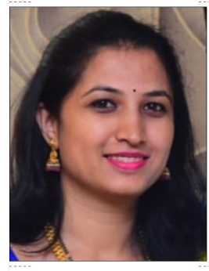
Designation | ASST.PROFESSOR
Educational Qualification | M.Sc. (PhD)
Experience in Years | Teaching: 9 years
Areas of Interest | GraphTheory
Aadhar Number | 846785420971
E-mail | supriyamd@ksit.edu.in

EducationalDetails
 | Examination/  Degree | College/University | Year of  Passing
 | UG-B.Sc.(PMCs) | FMKMC College, Madikeri, Mangalore University | 2009
 | PG-M.Sc.(MATHEMATICS) | University of Mysore, Manasa Gangothri, Mysore | 2011
 | PhD | Siddaganga Institute of Technology, Tumakuru (Under Visvesvaraya Technological University, Belgavi) | Pursuing
Publications
Journal Publications:
- Research article entitled ““Soft graph on a distance-2 of a minimal dominating set” published in the International Journal of Information Technology (Int. j. inf. tecnol. (April 2025) 17(3):1839–1844. https://doi.org/10.1007/s41870-024-02372-1
- Research article entitled “Soft Bipartite Graph: A New Bipartite Graph in the Horizon” published in the Journal of Information Systems Engineering and Management,2024, 9(4). https://doi.org/10.52783/jisem.v9i4.86.
- Research article entitled “Soft graph on a minimal edge dominating set” published in the Journal of Mines, Metals and Fuels, 71(12D): 213-220; 2023. https://doi.org/10.18311/jmmf/2023/47292
Book Chapters:
- Supriya, M. D., and P. Usha, “Soft expert graph and its applications”, in Engineering Science and Technology: Innovations for the Future, Chapter 58; 495-399. CRC Press (2025) https://10.1201/9781003685876-58.

Conference Papers:
- Attended and presented a paper titled “Soft graph on a minimal edge dominating set” at the International Conference on Applied Research in Engineering Sciences (ICARES-2022) held on 24th and 25th November 2022 at Ramaiah Institute of Technology, Bengaluru.
- Attended and presented a paper titled “Soft expert graph and its applications” at the International Conference on Recent Innovations in Engineering Science and Technology (ICRIET-2025) held on 9th and 10th May 2025 at K S Institute of Technology, Bengaluru.
Awards
- Completed “Graph Theory” online course with a consolidated score of 92% conducted by NPTEL.
- Completed “Advanced Graph Theory” online course with a consolidated score of 87% conducted by NPTEL.
Professional Membership
1.
2.
3.

ContactDetails
Name: SUPRIYA M D
Official Address: #14, Raghuvanahalli, Kanakapura Road, Bangalore-560109.
Phone No: 9632510373
Alternate Email: mdsupriya.5@gmail.com

