K.S.INSTITUTEOFTECHNOLOGY
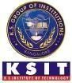
#14, Raghuvanahalli, Kanakapura Road, Bangalore-560109.
Faculty Name | REKHA R | 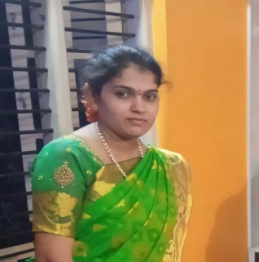
Designation | ASST. PROFESSOR
Educational Qualification | M.Sc.
Experience in Years | Teaching:3.10 years
Areas of Interest | Graph Theory
Aadhar Number
E-mail | rekhar@ksit.edu.in

Educational Details
 | Examination/  Degree | College/University | Year of  Passing
 | UG B.Sc. | National degree College, Bangalore University | 2014
 | PG M.Sc. | Central College, Bangalore University, Banglore | 2016
 | PhD
Publications
Journal Publications: 1.
Conference Papers: 1.
Awards
- Awarded for successfully completing the Course on Graph theory conducted by NPTEL from JAN- MAR 2025.

Professional Membership
1.
2.
3.

Contact Details
Name: REKHA R
Official Address:#14,Raghuvanahalli,Kanakapura Road, Bangalore-560109.
Phone No: 9945782790
Alternate Email: rjrekha87@gmail.com

