K.S.INSTITUTEOFTECHNOLOGY

#14, Raghuvanahalli, Kanakapura Road, Bangalore-560109.
Faculty Name | Sowmyarani C | 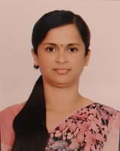
Designation | ASST. PROFESSOR
Educational Qualification | M.Sc.
Experience in Years | Teaching:3.6
Areas of Interest | Fluid dynamics
Aadhar Number | 5304 3178 2549
E-mail | sowmyaranic@ksit.edu.in

Educational Details
 | Examination/  Degree | College/University | Year of  Passing
 | UG B.Sc. | Sri gokula college, Bangalore university | 2011
 | PG M.Sc. | Bangalore city college, Bangalore university | 2016
 | PhD | -
Publications
Journal Publications: 1.
Conference Papers: 1.
Awards
1.
Professional Membership
1.
2.
3.

Contact Details
Name: Sowmyarani C
Official Address:#14,Raghuvanahalli,Kanakapura Road,Bangalore-560109.
Phone No: 6364542102
Alternate Email: sowmyabcc22@gmail.com

