K.S.INSTITUTEOFTECHNOLOGY
#14, Raghuvanahalli, KanakapuraRoad, Bangalore-560109.
FacultyName | Mrs. Shilpa Devangamath | 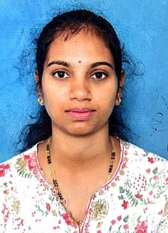
Designation | Instructor
EducationalQualification | Diploma CSE
ExperienceinYears | 3 years
E-mail | shilpapatil@ksit.edu.in


Educational Details
 | Examination/  Degree | College/University | Yearof  Passing
 | Diploma | Technical Education (DTE) Karnataka | 2010
 | S.S.L.C | Shri Jiveshwar Girls High School Hubli | 2003
Contact Details
Name: Shilpa Devangamath
Official Address:#14, Raghiuvanahalli, Kanakapura Main Road, Bangalore - 5600109
Alternate Email:sunita.shilpa.devangamath@gmail.com

