K. S. INSTITUTE OF TECHNOLOGY
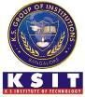
#14, Raghuvanahalli, Kanakapura Road, Bangalore-560109.
Faculty Name | SHWETHA K C | photo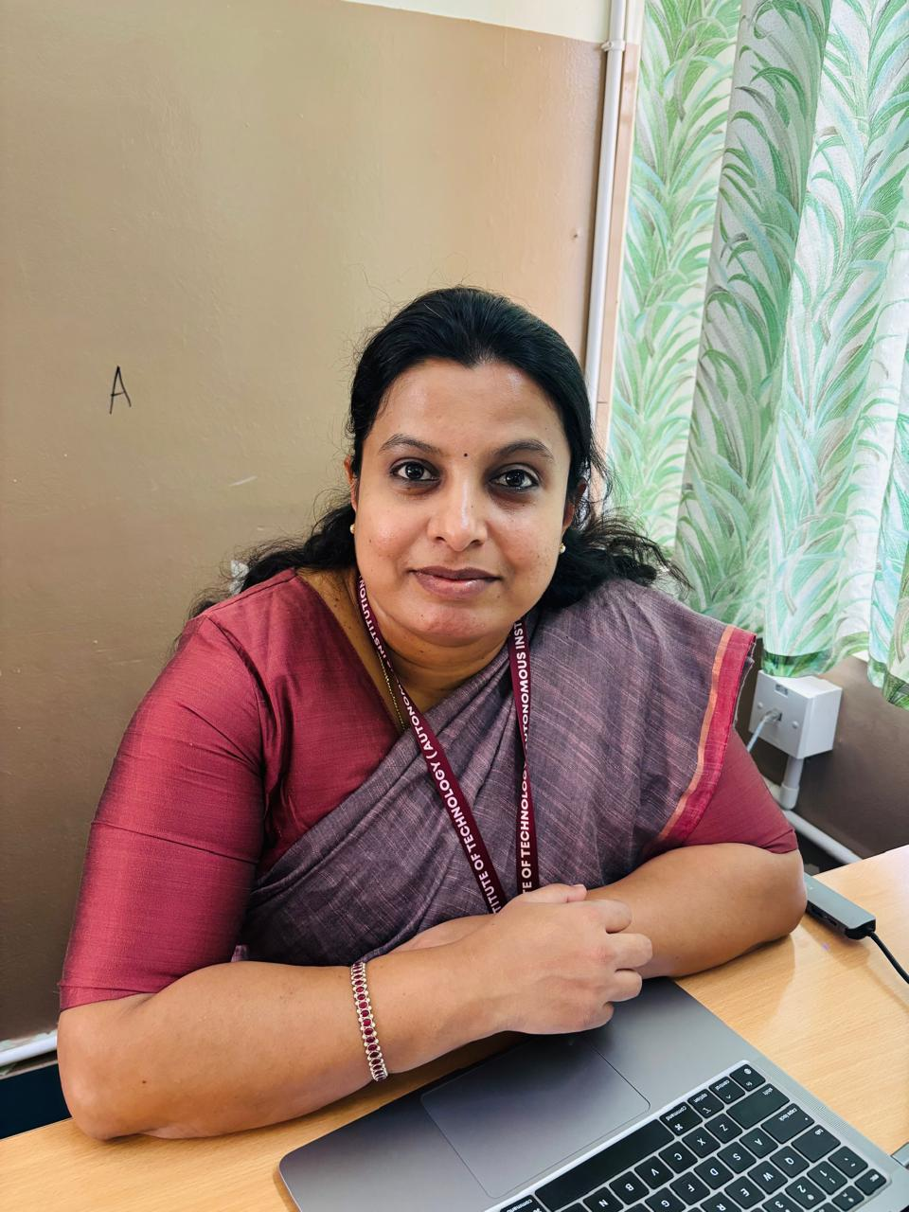
Designation | Assistant Professor
Educational Qualification | M.Sc (Phd)
Experience in Years | 8.5 years
Areas of Interest | Applied chemistry, Nanoscience & technology, Biology for Engineers, Environmental Science & E-waste Management
E-mail | swethakc@ksit.edu.in

Educational Details
 | Examination/  Degree | College / University | Year of  Passing
 | UG | Tumkur University | 2008
 | PG | Kuvempu University | 2010
 | M.phil | - | -
 | PhD | Persuing
Publications
Journal Publications:
INTERNATIONAL JOURNALS/ CONFERENCES:
1)Using Copper-Based Nanomaterials to Improve Plant Development by Means Of Microbial Siderophores Generation In The Plant Rhizosphere And Consequent Effect On Iron Absorption.
2)Development of Resin from Liquefied Wood by Solvolysis and Its Applications.

FDP:
- Successfully Completed FDP on Applied Chemistry subject VTU 2025 scheme on August 31 in EAST POINT COLLEGE OF ENGINEERING
- Successfully Completed FDP on EXPERIMENTAL NANOBIOTECHNOLOGY through NPTEL COURSE.
- Successfully Completed FDP on ANALYTICAL CHEMISTRY through NPTEL COURSE.

Awards
Best Paper Award in INTERNATIONAL CONFERENCES: Using Copper-Based Nanomaterials to Improve Plant Development By Means Of Microbial Siderophores Generation In The Plant Rhizosphere And Consequent Effect On Iron Absorption.

Professional Membership
RSC education society
Contact Details
Shwetha K C
Near Happy Valley School
Happy Valley Layout
Bangalore-560061
Email id: swethakc@ksit.edu.in

