Name of the Staff | 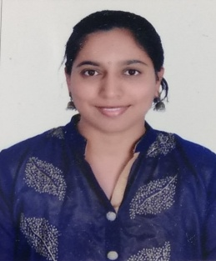 |  | photo
  DR. SHASHIKALA B S
Date of Birth | 18-02-1982 |  | photo
Unique ID |  |  | photo
Educational Qualifications | M.Sc., M.Phil.,Ph.D. |  | photo
Work Experience | Teaching | Research | Industry
Work Experience | 20 | 9
Area of Specialization | MATERIALS SCIENCE
Courses taught at UG/PG Level | APPLIED PHYSICS ( THEORY AND LAB)
Research Guidance (No.of Students) | NIL
No.of Papers Published in | National | International | Conferences
No.of Papers Published in | 2 | 6 | 10
Master (Completed/Ongoing) | COMPLETED
Ph.D (Completed/Ongoing) | COMPLETED
Projects Carried out
Patents (Filed & Granted)
Technology Transfer
Research Publications  (No.of papers published in National/  International Journals/Conferences) | 18
No.of Books published with details
(Name of the book, Publisher with ISBN,
year of publication etc.

