Name of the Staff | SUNIL KUMAR N |  | 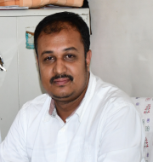
  photo
Date of Birth | 13-05-1986
Unique ID
Educational Qualifications | M Sc, B Ed.
Work Experience | Teaching | Research | Industry
Work Experience | 17 | 6 | NIL
Area of Specialization | MATERIALS SCIENCE
Courses taught at UG/PG Level | APPLIED PHYSICS ( THEORY AND LAB)
Research Guidance (No.of Students) | NIL
No.of Papers Published in | National | International | Conferences
No.of Papers Published in | 4 | 5 | 6
Master (Completed/Ongoing) | COMPLETED
Ph.D (Completed/Ongoing) | Ongoing
Projects Carried out | NIL
Patents (Filed & Granted) | NIL
Technology Transfer | NIL
Research Publications  (No.of papers published in National/  International Journals/Conferences) | 8
No.of Books published with details  (Name of the book, Publisher with ISBN,  year of publication etc. | NIL

