Name of the Staff | 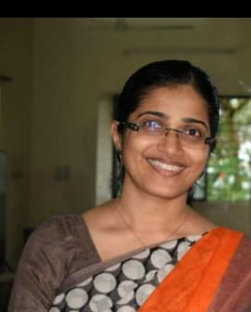 |  | photo
  Dr. Sheeja Krishnan
Date of Birth | 21.03.1978 |  | photo
Unique ID |  |  | photo
Educational Qualifications | M.Sc., Ph.D. |  | photo
Work Experience | Teaching | Research | Industry
Work Experience | 18 | 21 | NIL
Area of Specialization | Semiconductor Physics, nanotechnology
Courses taught at UG/PG Level | APPLIED PHYSICS ( THEORY AND LAB)
Research Guidance (No.of Students) | 4
No.of Papers Published in | National | International | Conferences
No.of Papers Published in | 1 | 18 | 2
Master (Completed/Ongoing) | COMPLETED
Ph.D (Completed/Ongoing) | COMPLETED
Projects Carried out | 2
Patents (Filed & Granted) | Nil
Technology Transfer | Nil
Research Publications  (No.of papers published in National/  International Journals/Conferences) | 21
No.of Books published with details  (Name of the book, Publisher with ISBN,  year of publication etc. | Electron Irradiation Effects in Cadmium Telluride and Silicon Devices, LAP Lambert Academic Publishing, 978-3838307145, 2010,

