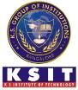
K.S. INSTITUTE OF TECHNOLOGY, BANGALORE - 560109
DEPARTMENT OF MASTER OF COMPUTER APPLICATIONS
TEACHING AND LEARNING
CONTENT BEYOND SYLLABUS REPORT

Academic Year | 2024-25
Name of the Faculty | Priyanka. M
Course Name /Code | Software Engineering/MMC204
Semester | II
Topics Covered | Learning Software Engineering and its use cases.
Date | June-2025
No. of Participants | 31
Objectives/Goals | Apply AI in software engineering concepts, life-cycles, SRS documentations, design concepts and architectures.  Implement different types testing and debugging techniques.
ICT Used/Certification | Infosys Springboard
Certification in Software Engineering – Infosys Springboard
All the students have successfully completed certification in Software Engineering from Infosys Spring board. This certification will help them in demonstrating proficiency in implementing AI in software engineering concepts, life-cycles, SRS documentations, design concepts and architectures. They have gained knowledge on using AI in software engineering concepts based on industry trend.
Relevant POs | PO1, PO2, PO4, PO7, PO8
Proofs (Photographs/Videos/Reports/Charts/Models)
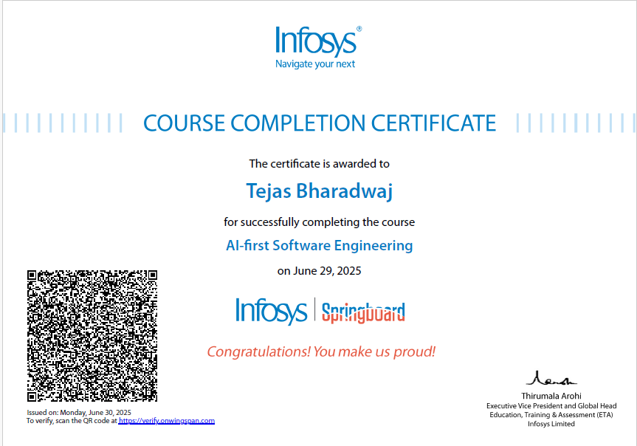
Signature of Faculty Incharge Signature of HOD

