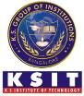
K.S. INSTITUTE OF TECHNOLOGY, BANGALORE - 560109
DEPARTMENT OF MASTER OF COMPUTER APPLICATIONS
TEACHING AND LEARNING
CONTENT BEYOND SYLLABUS REPORT

Academic Year | 2024-25
Name of the Faculty | Harilakshmi V M
Course Name /Code | Web Application Development /MMC205
Semester | II
Topics Covered | Learning Complete Front End Development
Date | June-2025
No. of Participants | 31
Objectives/Goals | Apply HTTP/HTTPS, DNS, CSS, JavaScript, and Version Control & Collaboration.  Implement Modern Frontend Frameworks, UI & Component Libraries, Testing & Debugging in Front end development.
ICT Used/Certification | Infosys Springboard
Certification in Complete Front End Development Journey – Infosys Springboard
All the students have successfully completed certification in Complete Front End Development Journey from Infosys Spring board. This certification will help them in implementing HTTP/HTTPS, DNS, CSS, JavaScript, and Version Control & Collaboration.
Implement Modern Frontend Frameworks, UI & Component Libraries, Testing & Debugging in Front end development. They have gained knowledge on web application development using HTML, CSS & JavaScript.
Relevant POs | PO1, PO2, PO4, PO8
Proofs (Photographs/Videos/Reports/Charts/Models)

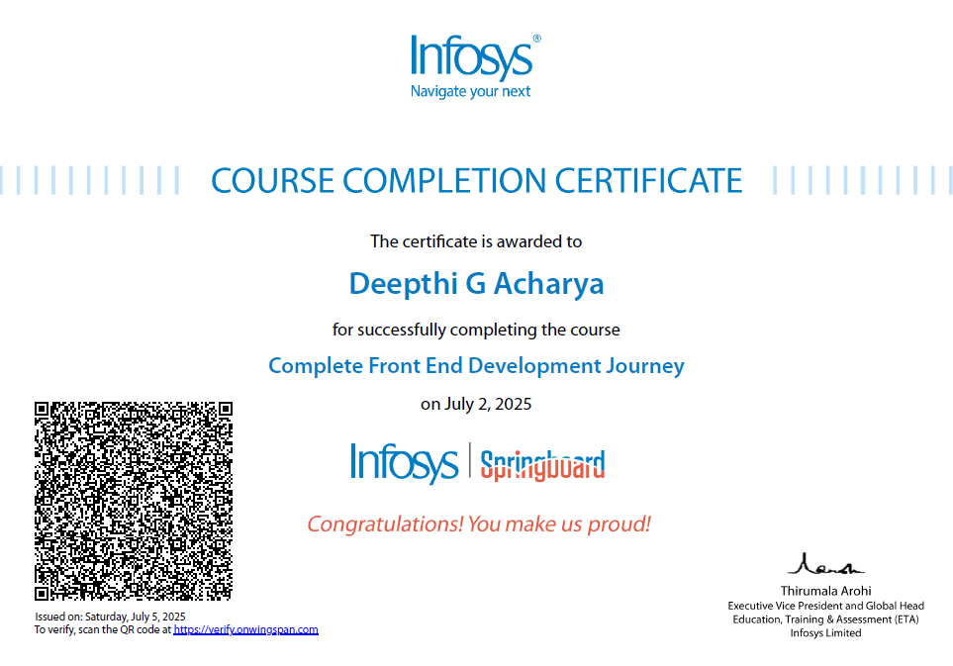

Signature of Faculty Incharge Signature of HOD

