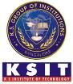
K.S. INSTITUTE OF TECHNOLOGY, BANGALORE - 560109
DEPARTMENT OF MASTER OF COMPUTER APPLICATIONS
TEACHING AND LEARNING
CONTENT BEYOND SYLLABUS REPORT

Academic Year | 2024-25
Name of the Faculty | Vijay M Kashyap
Course Name /Code | Machine learning and Data analytics using Python /MMC201
Semester | II
Topics Covered | Learning Machine Leaning with BigQuery ML: Building Regression Models.
Date | June-2025
No. of Participants | 31
Objectives/Goals | To help learners understand BigQuery ML fundamentals and gain skills in data preparation, regression modeling, and SQL-based model building and evaluation.
ICT Used/Certification | Infosys Springboard
Certification in Machine Leaning with BigQuery ML: Building Regression Models – Infosys Springboard
All the students have successfully completed certification in Machine Leaning with BigQuery ML: Building Regression Models from Infosys Spring board. This certification will help them to understand the fundamentals of BigQuery ML and develop the skills to prepare data, build, and evaluate regression models. This includes gaining knowledge of data preparation techniques, exploring both linear and logistic regression models, applying SQL-based workflows to create and train regression models in BigQuery ML.
Relevant POs | PO1, PO2, PO4, PO7,PO8
Proofs (Photographs/Videos/Reports/Charts/Models)

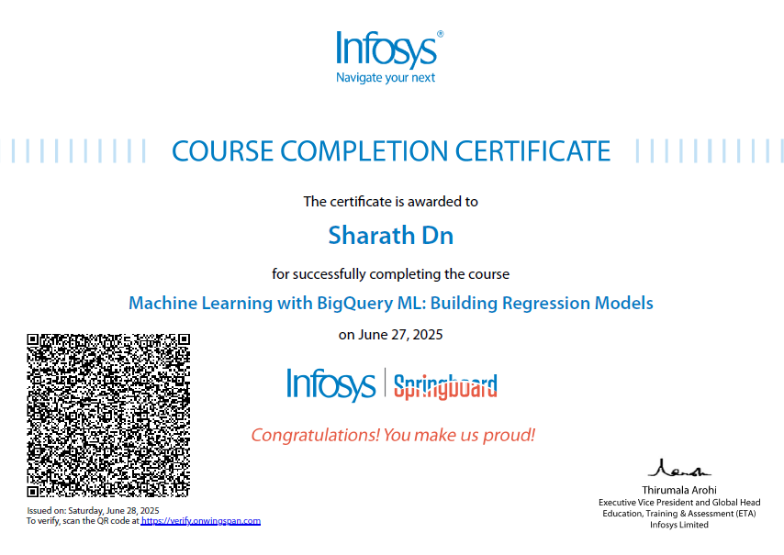

Signature of Faculty Incharge Signature of HOD

