
K.S. INSTITUTE OF TECHNOLOGY, BANGALORE - 560109
DEPARTMENT OF MASTER OF COMPUTER APPLICATIONS
TEACHING AND LEARNING
CONTENT BEYOND SYLLABUS REPORT

Academic Year | 2024-25
Name of the Faculty | Dr. Sneha Girish
Course Name /Code | Database Management Systems/MMC103
Semester | I
Topics Covered | - Understanding NoSQL databases and their advantages.  - Basic CRUD (Create, Read, Update, Delete) operations in MongoDB.
Date | 05-03-25
No. of Participants | 30
Objectives/Goals | To explore NoSQL databases, including MongoDB, Cassandra.  To learn CRUD operations.
ICT Used | LCD
CRUD refers to the four basic operations of persistent storage:
- Create → Insert new data into a database.
- Read → Retrieve data from a database.
- Update → Modify existing data.
- Delete → Remove data from a database.

Expanding CRUD: Beyond Basics

Batch Processing
- Bulk Inserts: Instead of inserting one record at a time, perform batch inserts for better performance.
- Bulk Updates: Update multiple rows at once instead of running multiple single queries.
- Bulk Deletes: Deleting large amounts of data efficiently.
Transactions in CRUD
Transactions ensure atomicity, meaning all CRUD operations in a sequence are completed successfully or none are applied.

Security Considerations in CRUD
- SQL Injection Prevention: Use prepared statements.
- Validation & Sanitization: Validate input before performing CRUD operations.
- Authentication & Authorization: Use JWT, OAuth, or API keys to restrict access.

Performance Enhancements
- Caching with Redis: Reduce database calls for read-heavy applications.
- Database Sharding: Distribute large datasets across multiple servers.
- Asynchronous Processing: Use background jobs for intensive CRUD operations.

Real-World Applications
- E-commerce: CRUD is used for managing products, orders, and users.
- Social Media: Posts, likes, comments follow CRUD patterns.
- Banking Systems: CRUD is crucial in account management, transactions, and logs.

Relevant POs | PO1, PO2, PO3, PO4, PO8
Proofs (Photographs/Videos/Reports/Charts/Models)

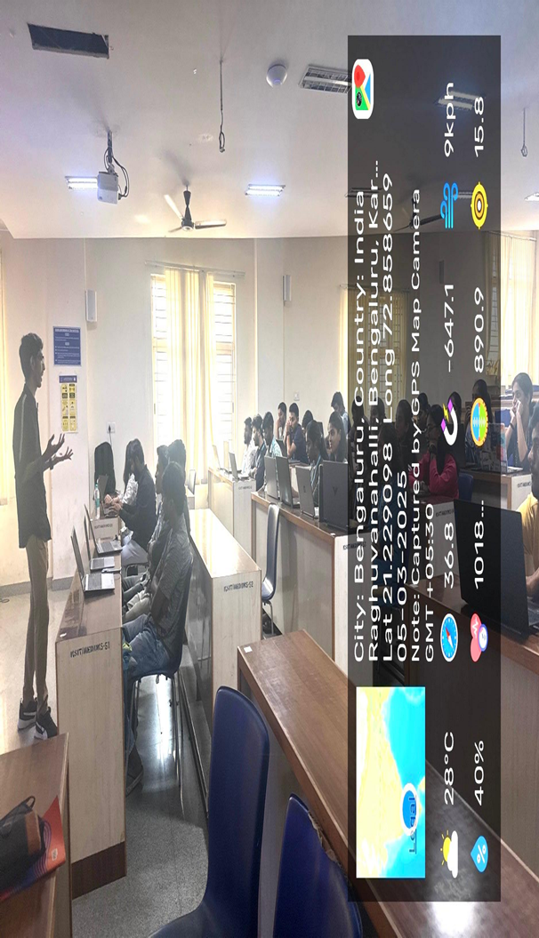

Signature of Faculty Incharge Signature of HOD

