K.S.INSTITUTEOFTECHNOLOGY
#14,Raghuvanahalli,KanakapuraRoad,Bangalore-560109.
Faculty Name | MAMATHA C | 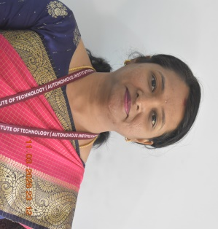
Designation | ASSISTANT PROFESSOR
Educational Qualification | BE.M.TECH
Experience in Years | 7yrs
Areas of Interest | ADA,C,Python,DATA STRUCTURES,Software Engineering
E-mail | Mamatha.c@ksit.edu.in

Educational Details
 | Examination/  Degree | College/ University | Year of  Passing
 | UG | BE(ISE)-JVIT,VTU | 2009
 | PG | M.TECH(CSE) | 2014
 | PhD
Publications
Journals:-
1.MEDICO specialized medicine guidance& blood bank assistance.
2.Bloodgroup detection using finger print.
3.SMART health diet planner
Conferences:-
1.From diagnosis to treatment: a systematic review of machine learning technologies in depression care management.

Patents:-
1.Artificial intelligence based battery cooling systems
Contact Details:
Name:Mamatha C,Dept.of CSD
Mamatha.c@ksit.edu.in

