 | K. S. INSTITUTE OF TECHNOLOGY  #14, Raghuvanahalli, Kanakapura Road, Bengaluru-560109.
Faculty Name |  |  | HARITHA Y | 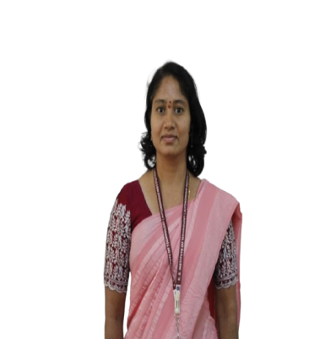
Designation |  |  | ASSISTANT PROFESSOR
Educational Qualification |  |  | M. Tech
Experience in Years |  |  | 10 Years
Areas of Interest |  |  | Artificial Intelligence
E-mail |  |  | harithareddyy121@gmail.com
Educational Details
Examination/ Degree |  | College/University |  |  | Year Of Passing
M. Tech(CS) |  | Sree Vidyanikethan Engineering College, Tirupati, A. P |  |  | 2016
B.E(CSE) |  | Sri Sai Institute of Technology & Science, Rayachoty, A.P |  |  | 2008
Publications
- Y Haritha & Dr. M Sunil Kumar. “ A Taxonomy on Vehicle Routing Problem” , International Journal of Computational Science , Mathematics and Engineering IJCSME Volume – 3,Issue – 1, January 2016.
Professional Membership
NIL
Contact Details
Name: Haritha Y
Official Address: #14 Rghuvanalli Kanakapura Road Bengaluru 109 Alternate Email: harithareddyy121@gmail.com

